**WDD130 Week 3 Assignment**

**Name:** Osahon Okoro

**Project**: Whitewater Rafting Site Plan

1. Logo

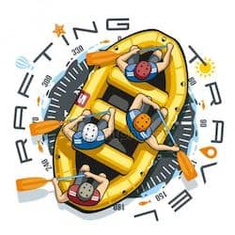

*Image File: "z-raftingcompas.jpg"*

1. Color Palette

* Primary Color: #391E3E
* Secondary Color: #D81E5B
* Accent 1 Color: #78735D
* Accent 2 Color: #B5C4C0
* Accent 3 Color: #FDF0D5

1. Typography

* Heading Font: Poppins
* Text Font: Lora

Font Examples in CSS:

font-family: 'Poppins', sans-serif; /* For Headings */

font-family: 'Lora', serif; /* For Body Text */

1. [Color Palette URL](https://coolors.co/391e3e-d81e5b-78735d-b5c4c0-fdf0d5): https://coolors.co/391e3e-d81e5b-78735d-b5c4c0-fdf0d5